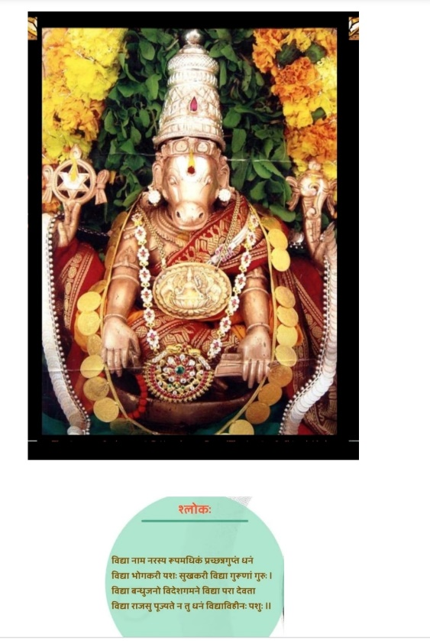

**ज्ञानानन्द मयं देवं निर्मलस्फटिकाकृतिम् ।**

**आधारं सर्व विद्यानां हयग्रीवम् उपास्महे।।** **Hayagriva Stotra- Swami Desikan**

With Acharyas’ Krupa and Lord Lakshmi Narasimhan’s Anugraham and Lord Lakshmi Hayvadana Perumal’s Krtm, this article about Panchanga is written by me (K.V. Krishnan) with the blessings of my Guru Sri. Dr. N.V.R.A Raja (**Astrology Jyotisha Kesari and Astana Vidhwan-Ahobila Mutt)** and his father **Poojya Sri. N.V. Raghava Chary Garu**, the Meena-2 Siddhantha Stapakar.

Our main aim in this article is, to introduce the concepts of Panchanga which is a part of Sanatana Dharma and Calendar in this Land for millions of years. Even before invaders’ times Panchanga was practiced by all of us in our day to day works.

Purpose of Daily reading of Panchanga:

Our ancestors Rushis and Munis, used this **Panchanga, Calendar for three main reasons:**

1. **For the mere reading of Pancha-Angas daily, (Five-Elements of Panchanga) gives us benefic results due to its divinity.** (We followers of Sanatana Dharma see God in every creation, and that divinity pays us back in some form or other, for our calm, and composed life.) For the mere reading of Pancha Angas, which provide us with benefits due to their divinity if read on a daily basis. A quote from Subhashithani is given below:

Thithyeshcha-Shreeyamapnothi, Vaaraath-Aayushyavardhanam

Nakshathraath-Harathepaapam, Yogaath-Roganivaranam

Karanaath- Karyasiddhishchaath, Panchangam dashamephalam

Thithyeshcha-Shreeyamapnothi- **Knowledge of Thithi bestows Wealth**

Vaaraath-Aayushyavardhanam- **Knowledge of Vaara increases Longevity**

Nakshathraath-Harathepaapam- **Knowledge of Nakshatra reduces effects (severity and duration) of Sins committed**

Yogaath-Roganivaranam- **Knowledge of Yoga as in Panchanga (combination of Grahas and Luminaries in a Horoscope) cures Diseases**

Karanaath- Karyasiddhishchaath-  **Knowledge of Karana ensures Success in work**

1. To know the day of the week and seasons of the year, to prepare ourselves for suitable protections inside and outside our houses, while travelling, and to carry out certain seasonal jobs for success in the result and for the welfare of the society.
2. To learn the main area, **Pancha Anga**, (Five elements of Panchanga) of the day along with their duration (timings) during the day and night, for starting any Veda stipulated Karmas. This is also called Electoral Astrology or Fixing a Muhurta for an event which is the **Sole purpose of Vedanga- Jyotisha** according to the classics **as a Vedanga. Muhurta fixing is considered very essential for any event in life also in addition to Veda stipulated Karmas for completion of the event without hinderance and the Karta, namely one who performs the Kriya has to complete the event successfully for which health has to be good and permit.**

**Panchanga**:

is a part of Vedanga Jyotisha, and Jyotisha itself is an Angam of Veda. There are six Angas to Veda, (our Sanatana Dharma Rule book), called Shastra. Shastra is defined as **Shasanat Shastra:** Shasanat in Sanskrit means, Guide, Rule, Order etc. Veda gives us even before we are born a Conduct and Rule book to follow for peaceful survival after birth and to be helpful to society for the Sanatana Dharma to flourish. It is like a Traffic Rule Book, for us to travel on the Life with different type of relations and creatures without hit or trouble. However, since the statements made in the, Sankritised Vedas, are not easily understood by everyone even with knowledge of Sanskrit Language, our ancestors created six additional Grantas, Collection of documents for the correct understanding of the Veda which primarily tells us how to conduct ourselves and be useful to the society, when we systematically learn them through a Guru who is a practitioner of these rules already and benefited by them in real life.

**These angas are:**

**1.Siksha,2. Chandas, 3. Vyakarana, 4. Nirukta, 5. Jyotisha, 6. Kalpa**

Each of these six angas have a specific role to play in making us understand and interpret the meanings of the Vedas.

In addition to Vedas, one becomes a fully knowledgeable person only when he/she studies, **Puranas, Itihasas, Smrutis** along with Vedas. And with this knowledge, if he enters into the Road of Life, he could manoeuvre in it easily and without troubles on the way and safely reach the destination. (Destination for anyone born is to attain Liberation from Birth-and Death Cycle).

This statement is made in Veda itself, that one becomes a fully knowledgeable person only when he/she studies, under a Guru, **Puranas, Itihasas, Smrutis** with their meanings along with Vedas,

**इतिहास पुराणाभ्यां वेदंसमुपंवृहयेत्।**

**बिभेत्यल्पश्रुताद् वेदो मामयंप्रहरिषयति।।** **Maha Bharat**

Jyotisha is therefore a Shastra, which makes us understand the nuances of Veda Karmas and their timings, when and where these Karmas have to be started, and completed. Timing is the essence of this branch of Veda, for carrying out Karmas and Panchanga which is one of the Instruments or tools used to decide timings of Veda stipulated Karmas.

We will see more about Panchanga in future articles to come.